**Test for Thursday 21st**

**Attempt all Questions**

**Question 1**

You have been asked to maintain an existing system and have been presented with the object-oriented code below. To aid your understanding of the system draw a class diagram to represent this information:

public class Module {

private int moduleCode;

private String moduleName;

private int noOfCredits = 20;

public Module(int mno, String name)

{

moduleCode=mno; moduleName=name;

}

public Module(int mno, String name, int noc)

{

moduleCode=mno;

moduleName=name;

noOfCredits = noc;

}

}

public class Student

{

private int studentNo;

private String studentName;

private static int studentCount = 0;

public Student(int sno, String name)

{

studentNo=sno;

studentName=name;

studentCount++;

}

}

public class Registration

{

private Student aStudent;

private Module aModule;

private int result;

public Registration(Student s, Module m) {

aStudent = s;

aModule = m;

}

public void setResult (int mark) {

if ((mark >= 0) && (mark <=100))

result = mark;

else

System.out.println("ERROR: not a valid mark");

}

}

**Question 2**

Write a class named Array that contains an array of integers as data member. The class contains the following member functions:

* A constructor that initializes the array element to 0
* Input function to input the values in the array.
* Display function to display the values of array
* A member function to make Odd values of the array three times (multiply by 3)

**Question 3**

Sketch what the following drawIt() method will draw in the graphics pane, if the user types 100 when asked for the size?

public static final double width = 50;

public void drawIt()

{

double size = UI.askDouble("Enter the size:");

UI.drawRect(250, 150, width, size );

UI. fillOval (150, 50, size , width);

UI.drawLine(width, size , width, 2 ∗ size );

}

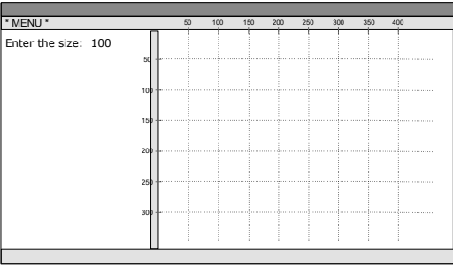

**Question 4**

Suppose our task is to write code to read a sentence from the user and print out the words in the sentence one word per line of output. It prints the words only: it doesn't print the period at the end of the sentence.

A sentence is one or more words ending with a period. For example:

user input (Test case 1):

This is a sentence.

output for Test case 1:

This

is

a

sentence

**Question 5**

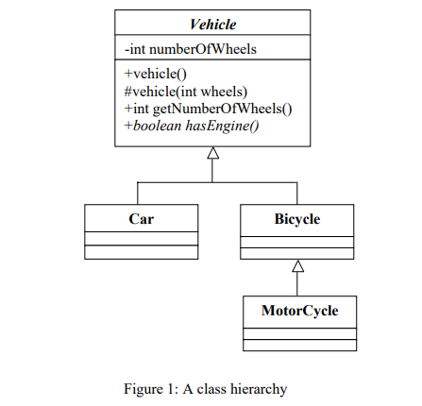

Consider the class hierarchy of vehicles shown in Figure 1, with the following additional information:

• Cars always have four wheels;

• Bicycles and their subclasses always have two wheels.

Note: there are only default (i.e. parameter-less) constructors available to the clients of the hierarchy.

1. Convert the hierarchy of Figure 1 to Java
2. Describe overriding and method overloading. Write some code to show an example.

**Question 6**

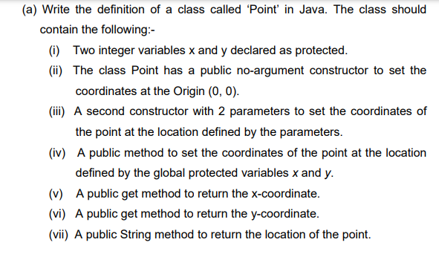

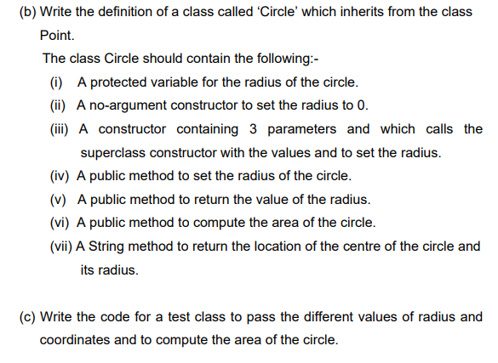

**Question 7**

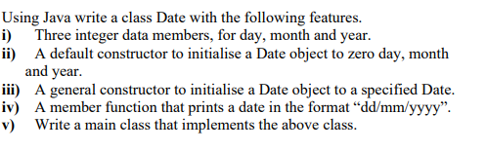

**Question 8**

